EV MARKET



SEGMENTATION

ANALYSIS

**Nirujogi Sai Yashmitha**

# ABSTRACT

Despite the prevailing reliance on oil as the primary energy source for over 90% of global automotive transportation, an increasingly prominent trend has emerged wherein efforts are being made to explore alternative fuel options for automobiles.

As a result, there is an increasing amount of discourse surrounding electric vehicles (EVs). The internal combustion engine (ICE) generates power through the combustion of a mixture of gasoline and gases, while an electric vehicle (EV) utilizes an electric motor as its primary source of propulsion. Consequently, the electric vehicle is being regarded as a prospective automobile for the next generation.

The utilization of electric vehicles presents a potential remedy for the escalating levels of worldwide air pollution, thereby posing a significant challenge to the achievement of sustainable development goals. Electric vehicles (EVs) have emerged as a crucial component in India's energy and mobility domains, primarily driven by the nation's pressing requirement for enhanced infrastructure and more favorable governmental regulations.

The current market share for electric vehicles (EVs), hybrid electric vehicles (HEVs), and plugin hybrid electric vehicles (PHEVs) in India is less than 1%. Contemporary transportation systems heavily rely on the utilization of fossil fuels. The emission of greenhouse gases into the Earth's atmosphere leads to the exacerbation of air pollution and the phenomenon of global warming.

India's transportation industry has experienced significant growth and expansion in recent years. There is a growing disparity between domestic crude oil production and domestic crude oil consumption. Approximately 70% of India's yearly oil demand is satisfied through imports. Therefore, there is an urgent need for research on the causes and challenges pertaining to the development of environmentally sustainable transportation alternatives. Electric vehicles (EVs) represent a viable, environmentally friendly, and sustainable mode of transportation.

The recent scenario of the road transportation sector can be highlighted as:

* Energy consumption: 524 million tons of oil equivalent
* Vehicle to people ratio: 1:56.3
* Per capita energy: 442 kg of oil equivalent
* GHG emissions: 1730 million tons of CO2 equivalent
* Electric Vehicles sold (2016): 25000 (all) and 2000 (cars)

While the population and emissions are higher than average, the ratio of vehicles to people is very high. With 1.726 billion metric tons of CO2 emissions, India is in third place. As a result, zero-emission transportation solutions, such as electric vehicle technologies, need immediate attention.

The following are some of the ways in which EVs, HEVs, and PHEVs (Plug-in Hybrid Electric Vehicles) may be better for use on Indian roads:

1. At the slow speeds typical of driving in India, hybrid or electric powertrains are more efficient than a conventional internal combustion engine.

2.In the average Indian road journey, a significant amount of energy is wasted when braking, but this is almost recovered by a HEV or EV thanks to regenerative braking.

1. Unlike conventional vehicles, HEVs and EVs waste no fuel when idling, and traffic congestion in India causes more idle time than in the United States or Europe.
2. Compared to the United States and Europe, the average distance driven in India is substantially less, therefore there is no range anxiety while using an electric vehicle.
3. There is a need for high-efficiency electric cars because of the large traffic volumes and short distances that characterize urban driving cycles.

# MARKET OVERVIEW

By Vehicle Type, the market is segmented into Passenger Cars, Commercial Vehicles, and Two- and Three-wheelers.

By Power Source Type, the market is segmented into Battery Electric Vehicle, Plug-in Electric Vehicle, and Hybrid Electric Vehicle.

This report focuses on multiple sectors such as demographic, geographic and psycho-behavorial analysis.

Segmentation focus is also put in vehicle specifics related to constitution and performance.

In 2020, the valuation of the Indian Electric Vehicle Market amounted to USD 5 billion. It is projected to attain a value of USD 47 billion by the year 2026, exhibiting a compound annual growth rate (CAGR) surpassing 44% over the forecast period spanning from 2021 to 2026.

The outbreak of the COVID-19 pandemic has had a significant impact on the Indian Electric Vehicle Market. This impact is primarily attributed to disruptions in the supply chain and the suspension of manufacturing units as a result of ongoing lockdowns and travel restrictions implemented throughout the country. Nevertheless, the electric vehicle (EV) market in India is currently in its early stages of development. The projected growth rate is anticipated to be significantly higher during the forecast period as a result of diverse government initiatives and policies.

E-commerce enterprises, such as Amazon, are implementing strategies to incorporate e-Mobility solutions in their last-mile delivery operations with the aim of mitigating their environmental impact by reducing carbon emissions. India is currently engaged in the exploration and implementation of e-Mobility solutions for public transportation. As part of this initiative, the country has successfully introduced electric intercity buses in several prominent urban centers. Furthermore, it is worth noting that state governments are actively involved in implementing policies that promote the adoption of electric vehicles (EVs).

For example:

* Kerala aims to put one million EV units on the road by 2022 and 6,000 e-buses in public transport by 2025.
* Telangana aims to have EV sales targets for 2025 to achieve 80% 2- and 3-wheelers (motorcycles, scooters, auto-rickshaws), 70% commercial cars (ride-hailing companies, such as Ola and Uber), 40% buses, 30% private cars, and 15% electrification of all vehicles.

# DATA SOURCES

https://electricvehicles.in/electric-vehicles-sales-report-in-india-2018/ https://www.kaggle.com/karivedha/indian-consumers-cars-purchasing-behaviour

https://www.kaggle.com/datasets/divyanshusingh18/ev-cars-india-2023

https://e-amrit.niti.gov.in/home

<https://www.eai.in/india-ev-database><https://www.kaggle.com/datasets/kkhandekar/cheapest-electric-cars> <https://www.kaggle.com/datasets/vishalturare/ev-cars-available-in-india-till-oct2021>

# DATA PREPROCESSING

**LIBRARIES USED:**

This report focuses on multiple sectors of segmentation with respect to the EV industry, such as demographic, geographic, behavorial, vehicular, and many more. As a result, a varied set of Python dependencies or libraries have been utilized for data analysis and segmentation. They include:

* Pandas: Pandas is a Python library used for data manipulation and analysis; it provides data structures and functions needed to manipulate structured data, making it easy to filter, sort, and display data in a market segmentation project.
* NumPy: NumPy, short for Numerical Python, is a foundational package for numerical computations in Python. It's used to perform mathematical and logical operations on arrays and matrices, which can be helpful for complex computations in market segmentation.
* Matplotlib: Matplotlib is a plotting library for Python and is used to visualize data in the form of various graphical plots (like bar, scatter, histogram etc.). It can be used to illustrate the segmentation results.
* PCA (Principal Component Analysis): PCA is a statistical procedure that uses an orthogonal transformation to convert a set of observations of possibly correlated variables into a set of values of linearly uncorrelated variables. It's used in market segmentation for dimensionality reduction, especially when dealing with a large number of features.
* MinMaxScaler: This is a feature scaling tool from the sklearn library. It transforms features by scaling each feature to a given range (typically between 0 and 1), which can help normalize data.
* Seaborn: Seaborn is a Python data visualization library based on Matplotlib. It provides a high-level interface for creating informative and attractive statistical graphics, aiding in the visualization of market segments.
* KMeans: KMeans is a clustering algorithm from the sklearn library. It's commonly used in market segmentation to partition customers into different groups or segments based on similarities within data.

Steps of data preprocessing were many,due to using more than 5 datasets in the overall report, by the team. A few examples are given as follows:

1.For the dataset related to EV cars 2023,a few data cleanups had to be conducted.

* Car_name column is split into Brand and model. Splitting the car_name allows for more focused brand-level analysis and detailed comparisons between different car models.
* Convert units: Convert the car price from lakh and crores to the appropriate currency unit (e.g., Indian Rupees). Remove any extra characters such as commas, dashes, and "lakh" from the car price column.
* Look for any inconsistencies or errors in the dataset, such as conflicting information or incorrect values. Correct or remove such data points if necessary.
* Clean Drive Range of vehicles to KM and Power to bhp, remove any non-numeric characters from the power column.

1. The dataset gathered from e-amrit ,related to EV cars, had few errors ,such as
   * Changing non-numerical values to numerical values
   * Checking for null values and removing them
2. The dataset related to behavioral analysis, required some preprocessing before segmentation.
   * Double checking the percentage of empty entries column wise, to ensure no null entries.
   * A few incorrect entries in marital status, given as ‘m’, had to be changed to “Not married” after observing the dataset.
   * Memory usage of the dataset had to be checked for efficient runtime.

# SEGMENT EXTRACTION

Multiple ML techniques were used to analyse and predict the target segment. Usage of a varied range of datasets with different parameters required multiple analysis methods. They are:

K-Means

* K-Means is an unsupervised machine learning algorithm used to partition data into K distinct clusters based on their attributes.
* It involves iterative steps where each data point is assigned to the closest cluster centroid, and then each centroid is re-computed as the mean of its constituent data points.
* -It's very useful for market segmentation as it can help identify different customer groups based on their behavior, preferences, and other characteristics.
* -However, one challenge with K-Means is the need to specify the number of clusters (K) beforehand, which might not be straightforward in all cases.

WCSS (Within-Cluster Sum of Squares)

* WCSS is a metric used to evaluate the performance of clustering algorithms like KMeans. It calculates the total variance or spread within each cluster.
* In the context of K-Means, the aim is to minimize the WCSS. The lesser the WCSS value, the better the cluster.
* It can also be used to determine the optimal number of clusters by using the Elbow Method. This method involves plotting WCSS against the number of clusters, and finding the point where the decrease in WCSS starts to level off (the 'elbow').

PCA (Principal Component Analysis)

* PCA is a dimensionality reduction technique that transforms a large set of variables into a smaller one, while still preserving most of the information in the large set.
* It works by calculating the eigenvalues and eigenvectors of the data covariance matrix, which are then used to project the original data into a lower-dimensional space.
* In market segmentation, PCA can be useful when dealing with a large number of features or dimensions. It reduces the complexity of the data, making it easier to identify patterns and apply clustering algorithms.
* However, the trade-off of using PCA is that the reduced components may not be as interpretable as the original features.

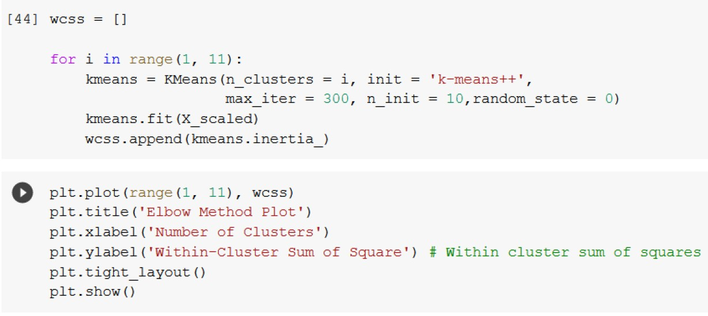

# MARKET SEGMENTATION REPORTS

The rest of the team report shows the analysis of individual members, their proposed target segments based on dataset parameters and marketing mix.

Since we can’t use categorical variables for K-Means Clustering, we will be encoding various attributes to a copy of the original dataset and use that for training the model.

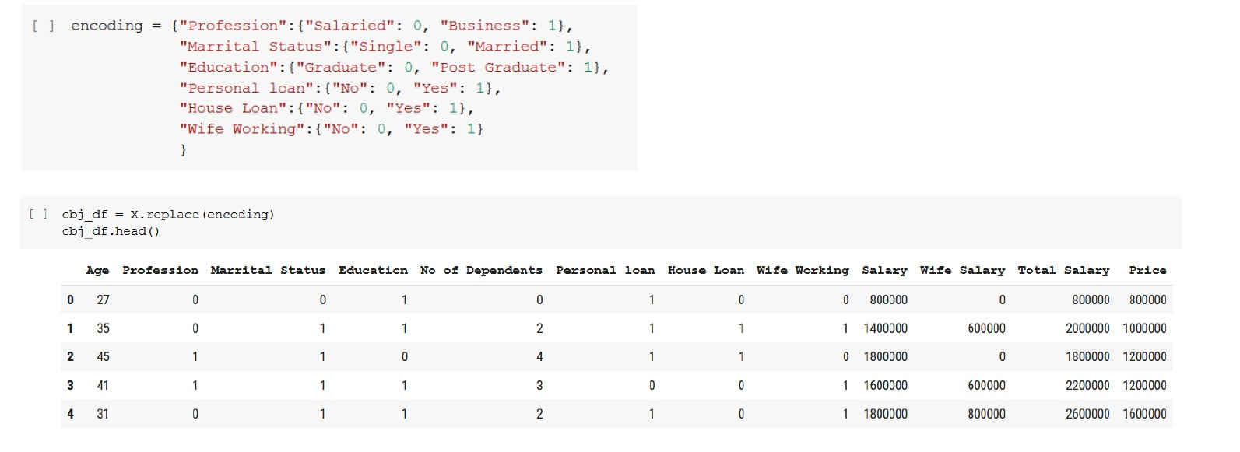

Before implementing K-means, we scale and normalize the dataset using MinMaxScaler.

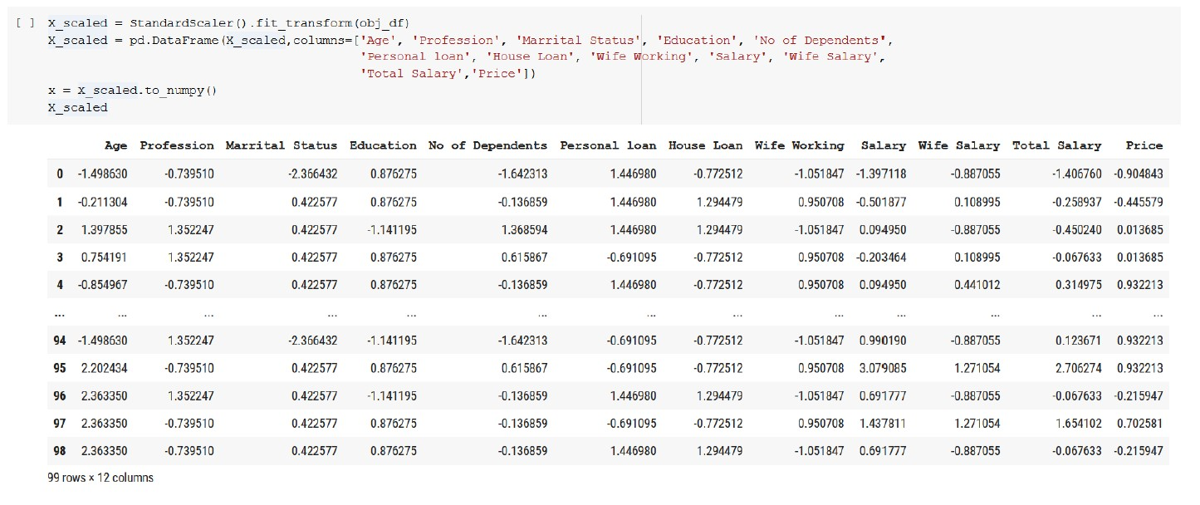

Initially we are trying to find the optimal K value using the Elbow Method wherein we will be finding the Within Cluster Sum of Square (WCSS) and try to find the point where it rapidly decreases which makes the graph look like an “elbow” there. The K value corresponding to that point is the optimal K value.

After looking into the plot, we can find that there are 2 points at which elbows are formed (which can be seen with the slight bent at K=3 and K=5). After finding the possible optimal K value, we will try to find the K value which provides us with the right clustering.

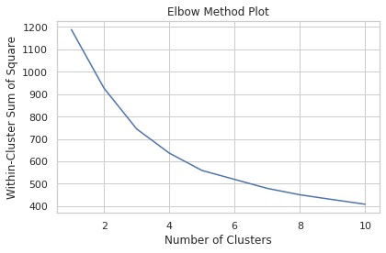

From the behavioral, psychographic, geographic and demographic analysis, we were able to see some attributes having an impact in the way of grouping consumers. However while looking into the clustered dataset, we were able to find 5 attributes that contributed most to the clustering (i.e., Age, Salary, Wife Salary, Total Salary, and Price). This can be seen in the pairplot done below for both K=3 and K=5 conditions.

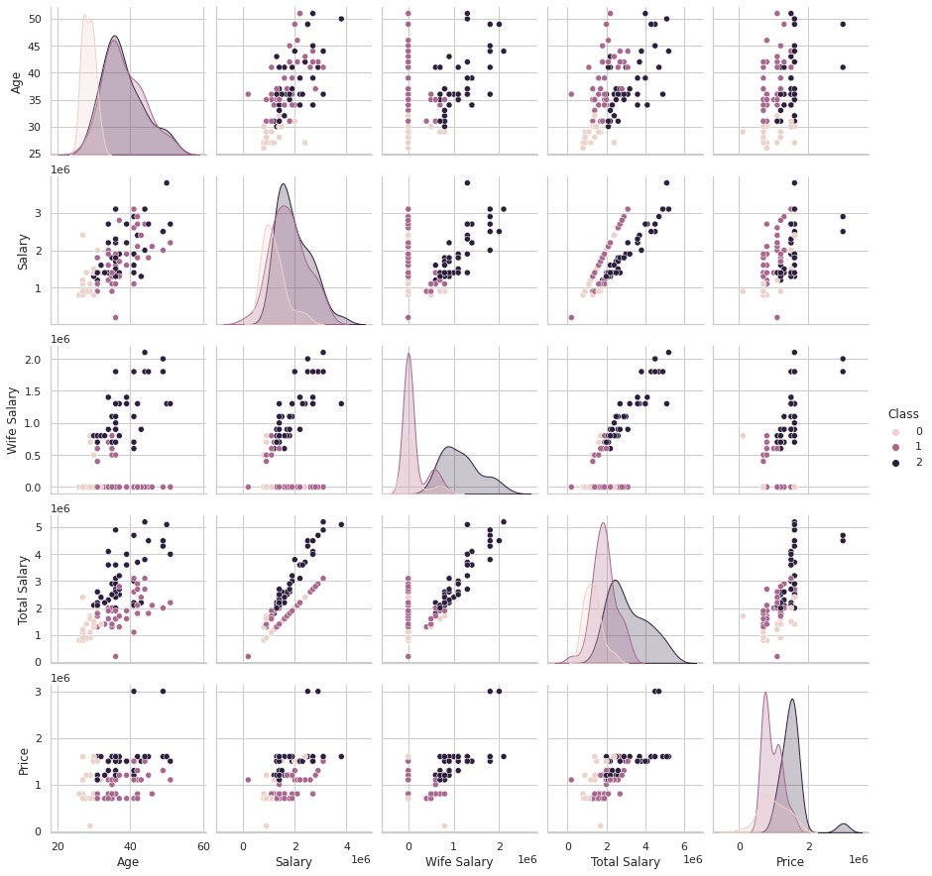

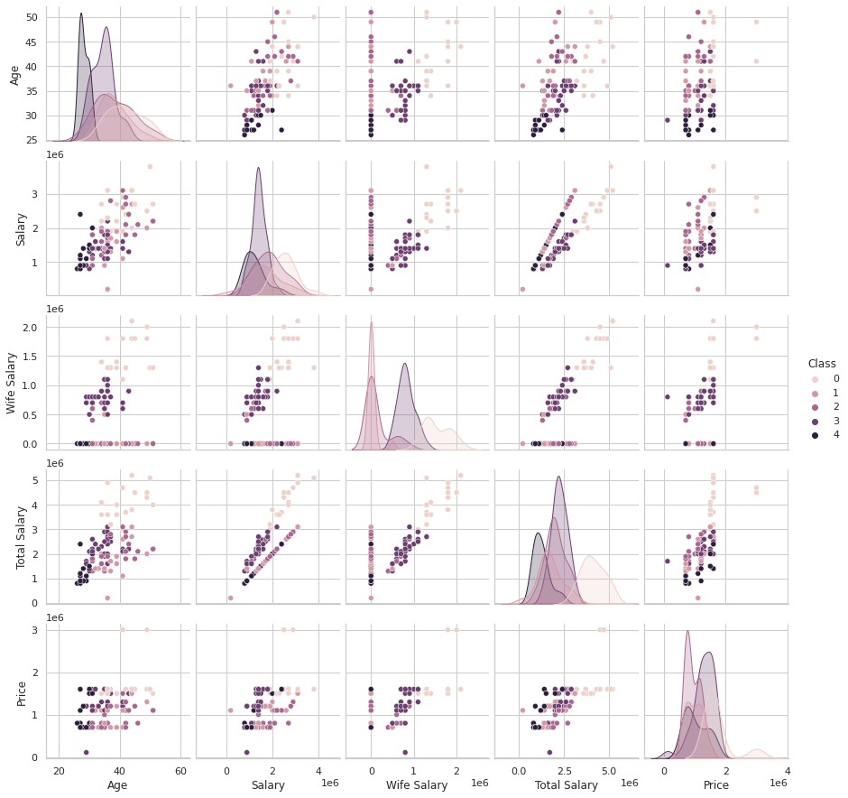

In the case of K=3,we observe clusters based on income divided into classes such as :

* Class 1 are the group of people who have Total Salary close to Salary (husband’s salary)
* Class 2 is the group of people who have Total Salary higher than Salary (husband’s salary)
* Class 0 are the group of people who have Total Salary close to Salary (husband’s salary) but their total salary is relatively less compared to other people.

In the case of K=5, we are able to see the dataset is being clustered into very small groups of people that the model recognizes as a trend which is however not the case. We don’t want to lose the homogeneity between our segments, therefore, going with K=3 will give the best results in the clustering analysis that is being done.

## TARGET SEGMENT

* In our study, it was observed that individuals belonging to younger age groups exhibit a preference for purchasing vehicles with lower price points. Consequently, the relatively higher cost associated with Electric Vehicles may potentially serve as a deterrent for this particular demographic.
* However, it is observed that individuals belonging to younger age groups exhibit a higher propensity to engage in the purchase of technologically advanced products, particularly Electric Vehicles (EVs), due to their heightened awareness of the environmental advantages associated with such products and their desire to actively contribute towards fostering positive environmental transformations.
* It is recommended that Electric Vehicles be targeted towards a demographic characterized by a willingness to adopt novel technologies and possessing sufficient discretionary income to make investments in such vehicles.
* It is likely that the age range of these individuals falls between 30 and 40 years.
* Individuals residing in urban areas that possess well-developed infrastructure and have access to educational resources pertaining to technology and its advantages are more inclined to exhibit a higher propensity for acquiring electric vehicles.
* Individuals who are married and have dependents exhibit a higher propensity to acquire an automobile, thus rendering them a viable target demographic.
* The average salary of individuals who purchase vehicles is approximately 30 lakhs, with the majority of automobile purchases falling within the price range of 10-20 lakh. Conversely, the demand for two-wheelers is comparatively lower. It is imperative to consider these aspects as well.

## MARKETING MIX

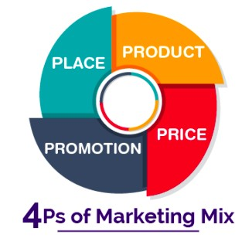

### PRODUCT

The choice of product would naturally be contingent upon the EV Startup in question. However, our analysis has indicated that, for the Indian market, it would be most advantageous to enter with two-wheelers due to their dominant market share in the automotive industry. The primary reason individuals opt to acquire a two-wheeler is due to its cost-effectiveness, which is further reinforced by the existing infrastructure.

EV Startup may consider exploring public transport vehicles as an additional product category, given the favorable government policies that encourage the transition to electric-powered engines in the public transportation sector.

### PRICE

The issue of affordability poses a significant challenge to the expansion of Electric Vehicles (EVs). It is imperative to consider that in order to attract consumers, the company's product must possess cost-effectiveness in terms of both initial purchase and ongoing maintenance. Ideally, the optimal price range for the product would be between 10 to 20 lakh, as it is within the range that is most commonly preferred by potential buyers.

### PLACE

Infrastructure is a crucial consideration that must be taken into account during the development and launch of any product. It is advisable to focus on major urban cities within the country, as these areas possess the necessary infrastructure to support targeted initiatives.

One additional rationale for focusing on urban cities is the higher probability of encountering a well-informed populace that is inclined to purchase Electric Vehicles due to their awareness of the environmental advantages associated with them.

### PROMOTION

The effectiveness of promotion strategies varies depending on the product being marketed. The most effective strategy for promotion involves disseminating knowledge to individuals regarding the advantages of electric vehicles (EVs), hybrid electric vehicles (HEVs), and plug-in hybrid electric vehicles (PHEVs) in comparison to conventional fuel-based automobiles. If the startup develops a cost-effective product, it should certainly be promoted.

## SEGMENT EXTRACTION

* Select Features: Choose the relevant features from the dataset that will be used for segment extraction. These features should provide meaningful information for clustering. Here Car_price ,Batter_cap Drive_range , Power, Charge_time, Brand are the selected features.
* Data Normalization: Normalize the selected features to bring them to a similar scale, ensuring that no single feature dominates the clustering process.
* Performing K-means clustering for segmentation:

Step 1: Perform Elbow Method for Finding Number of Clusters: To determine the optimal number of clusters for segmentation, we can use the elbow method. This method plots the within-cluster sum of squares (WCSS) against the number of clusters and identifies the point where the rate of decrease in WCSS begins to level off. This point indicates a good balance between the number of clusters and the compactness of each cluster.

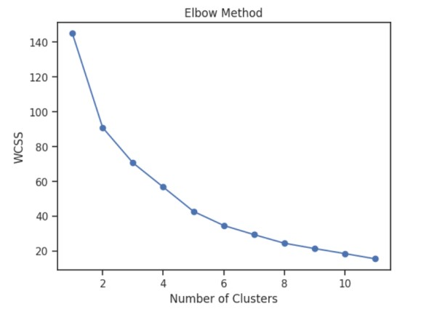

Fig. Elbow Method

Step 2: Perform K-means Clustering with 4 Number of Clusters: we have determined the optimal number of clusters as 4 from the elbow method, we can perform K-means clustering using that number of clusters.

Step 3: Display Cluster, Their Features, Properties, and Feature Importance: Each cluster is individually analysed and examined their features, properties.

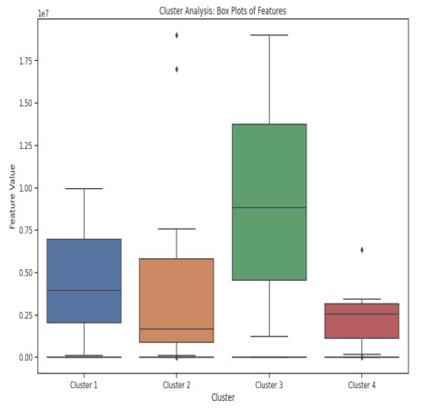

**PROFILING AND DESCRIBING POTENTIAL SEGMENTS:**

Based on the feature values and patterns within each cluster, we can interpret the segments as follows:

Segment 1: High-end Performance

* Car price: Moderate around 4.67 million
* Battery capacity: Moderate approx. 89.7 kWh
* Drive range: High approx. 702 km
* Power: High 359 kW
* Charge time: Low 2.67 hours

This segment represents high-performance electric vehicles with moderate prices, battery capacities, long drive ranges, and high power. These vehicles are suitable for customers who prioritize performance and are willing to pay a premium for advanced features and capabilities.

Segment 2: Affordable and Compact

* Car price: Moderate
* Battery capacity: Low
* Drive range: Moderate
* Power: low
* Charge time: Moderate

This segment represents affordable and compact electric vehicles with moderate prices, lower battery capacities, and moderate performance. These vehicles are suitable for customers looking for more budget-friendly options and practical city driving.

Segment 3: Luxury and Premium

* Car price: Very High
* Battery cap: Very High
* Drive range: High
* Power: very High
* Charge time: Moderate

This segment represents luxury and premium electric vehicles with very high prices, high battery capacities, and high performance. These vehicles offer a combination of luxury features, advanced technology, and long drive ranges. They are targeted towards customers who value luxury, prestige, and the latest innovations in electric vehicle technology.

Segment 4: low-range and Balanced

* Car price: low
* Battery capacity: low
* Drive range: moderate
* Power: moderate
* Charge time: High

This segment represents mid-range electric vehicles with moderate prices, balanced features, and performance. These vehicles offer a good balance between affordability, practicality, and performance. They are suitable for customers who are looking for a reliable electric vehicle with decent features and performance at a reasonable price point. These segment interpretations can provide insights into the characteristics and potential implications for business decisions. They help in understanding the target customer profiles, market positioning, pricing strategies, and product development efforts tailored to each segment.

**SELECTION OF TARGET SEGMENT:**

Based on the provided information and analysis, the selection of the target segment can be based on the following criteria:

1. Price Range: Consider the segment with a price range that aligns with your target market's affordability and willingness to spend on electric vehicles. Segment 2 and Segment 4 have relatively lower price ranges compared to Segment 1 and Segment 3, making them potentially more attractive to price-conscious customers.
2. Drive Range: If targeting customers who prioritize long drive ranges, Segment 1, Segment 3 and also segment 4 offer higher drive ranges of around 700+ km. These segments may be appealing to customers who require extensive range capabilities, such as frequent long-distance travellers or those without easy access to charging infrastructure.
3. Power and Performance: Segment 1 and Segment 3 offer higher power outputs, indicating superior performance capabilities. If targeting customers who value high power and acceleration, these segments may be more suitable.
4. Demographic Considerations: Consider the demographic characteristics of your target market. Segment 1 and Segment 3, with their higher price points and potentially more luxurious features, may attract customers who prioritize prestige and luxury in their vehicle choices. Segment 2 and Segment 4, with their more affordable price ranges, may appeal to a broader range of customers, including those who are more budget-conscious.
5. Market Demand: Evaluate the market demand for different segments based on factors like customer preferences, competitors' offerings, and market trends. Conducting market research and analyzing the potential demand for electric vehicles in each segment is essential to determine which segment has a higher growth potential and market opportunity. Ultimately, the selection of the target segment should be based on a combination of factors, including the market dynamics, customer preferences, and the business's strategic goals and capabilities.

**MARKETING MIX:**

To customize the marketing mix based on the resulting segments, you can consider the following strategies for each segment:

Segment 1: -

Product: Highlight the advanced features, long drive range, and powerful performance of the electric vehicles in this segment. Emphasize the luxury and premium aspects.

Price: Set the price at a higher range, reflecting the premium features and positioning of the vehicles.

Promotion: Use marketing channels that reach affluent customers, such as luxury lifestyle magazines, high-end events, and digital platforms targeting luxury car enthusiasts.

Place: Focus on exclusive showrooms and dealership networks in upscale locations or areas with high purchasing power.

Segment 2: -

Product: Highlight the value for money, reliability, and practicality of the electric vehicles in this segment. Emphasize the balance between price and features.

Price: Set the price at a competitive level, offering good value compared to other electric vehicle options.

Promotion: Utilize digital marketing channels, social media platforms, and online reviews to reach cost-conscious customers seeking reliable electric vehicles.

Place: Ensure availability of these vehicles in a wide range of dealerships and online platforms, making them easily accessible to potential buyers.

Segment 3: -

Product: Highlight the exclusivity, cutting-edge technology, and premium features of the electric vehicles in this segment. Focus on offering a superior luxury experience.

Price: Set the price at a premium level, reflecting the high-end positioning and exceptional features of the vehicles.

Promotion: Engage in strategic partnerships with luxury lifestyle brands, showcase the vehicles at high-profile events, and leverage digital marketing campaigns targeting affluent individuals.

Place: Establish dedicated luxury showrooms in prime locations, offer personalized customer experiences, and provide concierge services to cater to the unique needs of this segment.

Segment 4:

Product: Highlight the affordability, practicality, and environmental benefits of the electric vehicles in this segment. Focus on cost-saving aspects and ease of use.

Price: Set the price at a competitive and affordable level to attract budget-conscious customers.

Promotion: Utilize online advertising, social media platforms, and collaborations with environmentally conscious organizations to reach potential customers seeking affordable and eco-friendly transportation options.

Place: Ensure availability of these vehicles in a wide range of dealerships, online marketplaces, and rental services to make them easily accessible to a diverse customer base.

By customizing the marketing mix for each segment, you can effectively target the specific needs, preferences, and price sensitivities of different customer groups, maximizing the chances of successful market penetration and profitability.

## SEGMENT EXTRACTION

The ML techniques used in this segmentation are PCA, Kmeans clustering are some of the major clustering method used.

k-means clustering: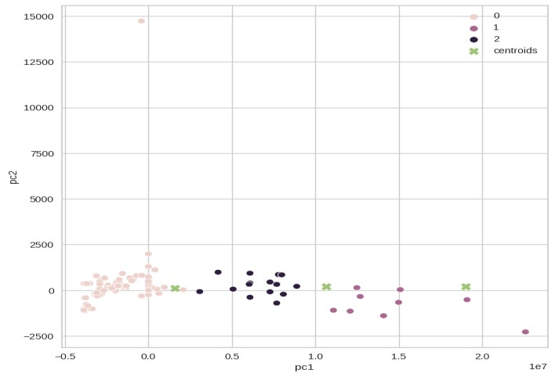

In the above figure we create 3 clusters by using K-Means Clustering and visualize for better understanding with Centroids.

## PROFILING AND DESCRIBING POTENTIAL SEGMENTS

1. Demographic segmentation

Demographic segmentation consists of dividing the market through different variables such as age, gender, nationality, education level, family size, occupation, income, etc. This is one of the most widely used forms of market segmentation, since it is based on knowing how customers use your products and services and how much they are willing to pay for them.

* Income: Income levels have a significant effect on consumer purchasing decisions. Those with higher-income levels may prefer luxury vehicles.

Conversely, individuals with lower income levels may prefer to get vehicles at the best deal and are likely to choose inexpensive products/services.

* Family size: Family size also determines consumers' purchase decisions. Those who have large family members may choose four wheelers and those who have less family members will choose two wheelers.

2. Psychographic segmentation

Psychographic segmentation consists of grouping the target audience based on their behavior, lifestyle, attitudes and interests. To understand the target audience, market research methods such as focus groups, surveys, interviews and case studies can be successful in compiling this type of conclusion.

* Lifestyle: A consumer whose profession is more time consuming than other average consumers , that consumer may select a vehicle who takes less time to charge a vehicle. This group of consumers only focus on the time required to charge an EV.
* Interests : Some consumers may have interest in particular manufacturing companies. Some consumers may like only vehicles made by the Tata company.
* Behavior : Behavior of consumers is the most important factor in the market segment. It shows what exactly consumers want from us? Some consumers may want an EV who will cover far distance per a charging. Customizing the Market Mix , The marketing mix refers to the set of actions, or tactics, that a company uses to promote its brand or product in the market.

## SELECTION OF TARGET SEGMENT

Target marketing involves breaking a market into segments and then concentrating your marketing efforts on one or a few key segments consisting of the customers whose needs and desires most closely match your product or service offerings. It can be the key to attracting new business, increasing sales, and making your business a success.

It can be concluded from below analysis that Range, Top Speed, Full charging time, Income and Types of Vehicles can be the most important segment categories for consumer purchasing decisions. These are the key factors who make markets different and similar at the same time. These segments have formed with distinct features which may indicate that their preferences for EVs are motivated by different factors.

## MARKETING MIX

The 4Ps make up a typicalmarketing mix - Price, Product, Promotion and Place.

* Price: Refers to the value that is put for a product. It depends on costs of production, segment targeted, ability of the market to pay, supply - demand and a host of other direct and indirect factors. There can be several types of pricing strategies, each tied in with an overall business plan.
* Product: Refers to the item actually being sold. The product must deliver a minimum level of performance; otherwise even the best work on the other elements of the marketing mix won't do any good.
* Place: Refers to the point of sale. In every industry, catching the eye of the consumer and making it easy for her to buy it is the main aim of a good distribution or 'place' strategy. Retailers pay a premium for the right location. In fact, the mantra of a successful retail business is 'location, location, location’.
* Promotion: This refers to all the activities undertaken to make the product or service known to the user and trade. This can include advertising, word of mouth, press reports, incentives, commissions and awards to the trade. It can also include consumer schemes, direct marketing, contests and prizes.

All the elements of the marketing mix influence each other. They make up the business plan for a company and handle it right, and can give it great success. The marketing mix needs a lot of understanding, market research and consultation with several people, from users to trade to manufacturing and several others.

## Market Segment Analysis :-

1. Based on Age

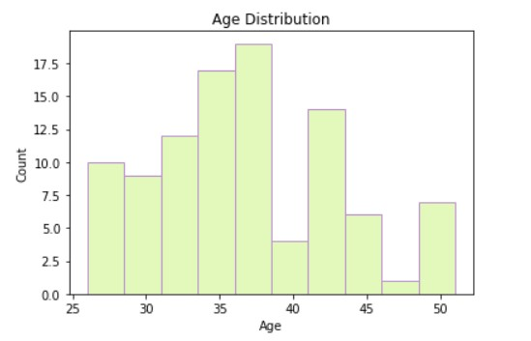

From the above Graph we can interpret that middle aged people are more concerned about the environment than the younger generation.

1. Based on Marital Status

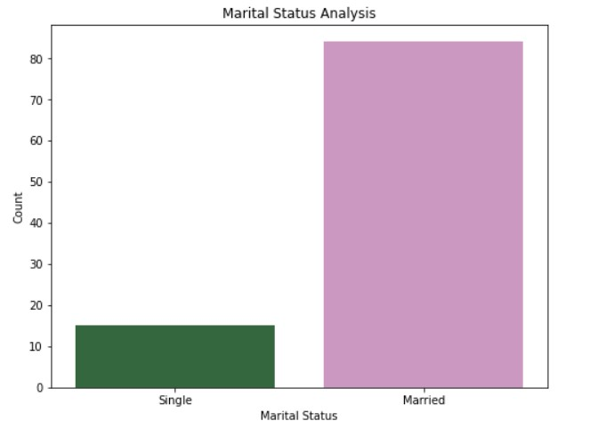

1. Based on Salary

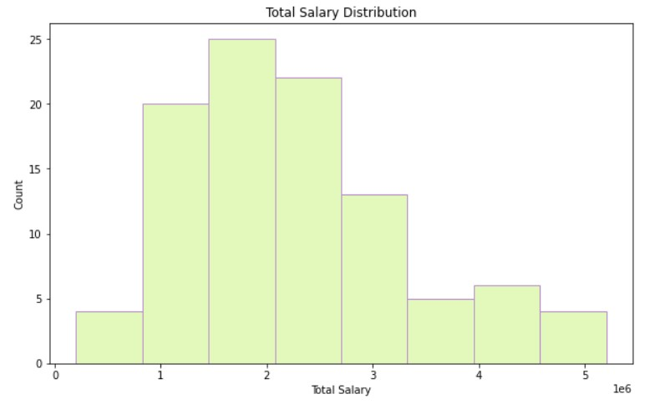

This shows that the Higher salaried people are opting for EVs, we see from later data analysis that usually EVs are more expensive than normal vehicles.

1. Car spending analysis:-

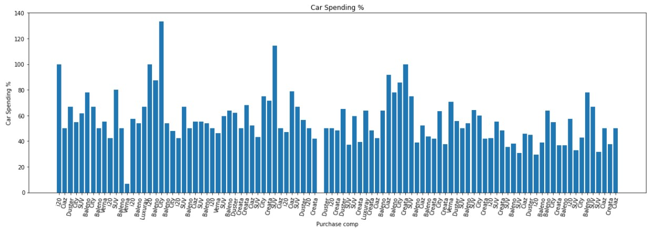

We can see cars like **Honda City and Baleno** are quite popular

1. Geographic Analysis:-

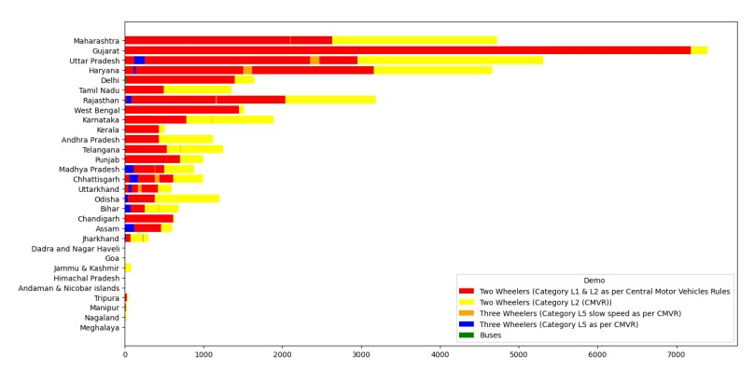

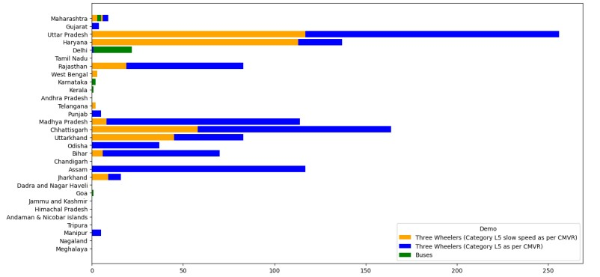

* Although Maharashtra leads in the total number of EV sales, most of the sales are in the passenger car segment.
* Gujarat has the highest proportion of two-wheeler (category L1 and L2) EV sales compared to the total sales in the state.
* Uttar Pradesh has the highest percentage of sales in two-wheelers (with maximum power not exceeding 250 watts) EVs of the total sales in the state.
* Similar observations can be made for other segments based on the percentage of sales.

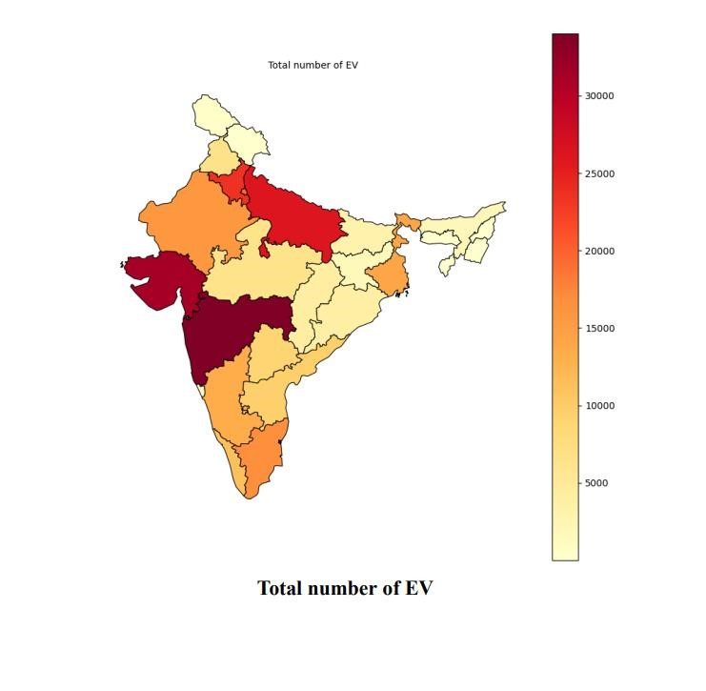

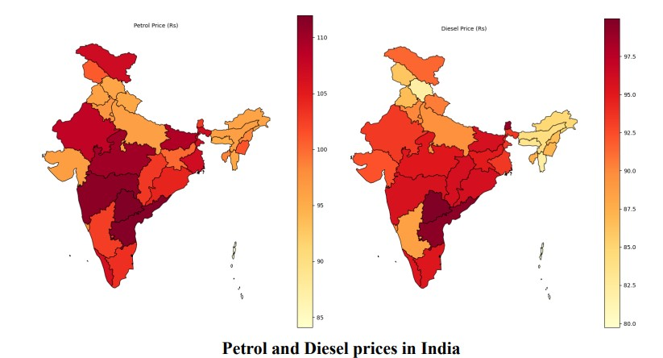

With rising petrol and diesel prices, electric vehicles are becoming a more cost-effective option compared to traditional petrol or diesel vehicles.. As the price of petrol continues to increase, electric vehicles become even more appealing to consumers as they provide long-term cost savings and can reduce the consumer's dependence on traditional fuels.

## Marketing Mix:-

The marketing mix consists of a range of strategies, including product, price, promotion, and place, that businesses employ to effectively target their intended market segments.

1. Product: EV manufacturers should offer a diverse range of products to appeal to different psychographic segments. This entails providing luxury EVs for high-income individuals, practical and affordable EVs for value-conscious consumers, and eco-friendly EVs for those who prioritize sustainability.
2. Price: The pricing strategy for EV manufacturers should take into account the affordability and value preferences of various market segments. This may involve offering financing options, incentives, and segment-specific discounts to make EVs more accessible to different consumer groups.
3. Promotion: To effectively promote their EV products, manufacturers should tailor their promotional activities to align with the interests and preferences of distinct segments. This could entail implementing targeted social media campaigns, leveraging influencer marketing, and organizing events that cater to specific psychographic segments. For example, sponsoring environmental events for eco-conscious consumers, participating in tech fairs for tech-savvy buyers, or showcasing at auto shows to attract early adopters
4. Place: A well-designed distribution strategy is essential for reaching the desired psychographic segments. EV manufacturers can establish partnerships with dealerships, develop charging infrastructure in urban areas, and offer home charging solutions to cater to convenience-oriented segments.

To succeed in the Indian EV market, companies need a comprehensive understanding of the unique requirements, preferences, and motivations of diverse psychographic segments. This understanding informs the development of an effective marketing mix that tailors product offerings, pricing strategies, promotional activities, and distribution channels to cater to the specific needs of each segment. By doing so, companies can successfully engage their target audience and drive widespread adoption of EVs in India.